Managing requests and complaints | MSP-02
Maintenance System Procedure | MSP-02
This procedure explains how to document, review, track and action public and Council enquiries. These are managed through Councils Complaints Register which records all complaints and enquiries.
Procedure
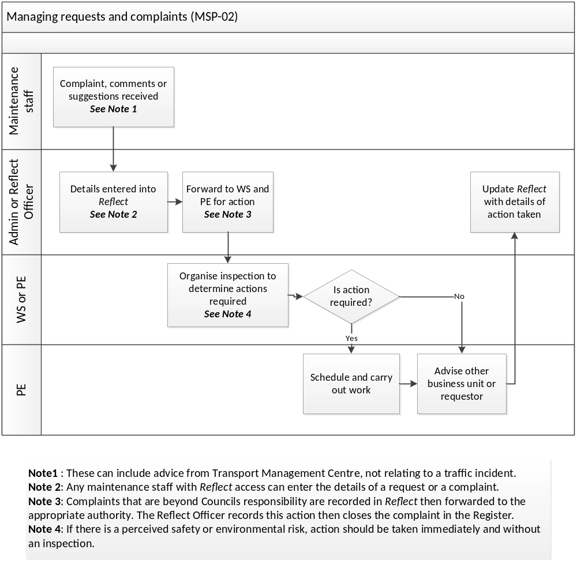
Road Project Officer

Reflect Officer

Maintenance Staff
Works Overseer

Forward to TfNSW Coordinator for action
See Note 3

